|  |  |  |
| --- | --- | --- |
| CDR | April 25  2016 | |
|  | | Critical Design Review |

|  |  |  |  |
| --- | --- | --- | --- |
| **Revision record** | | | |
| Version | Date | Attendees | Comment |
| 1.0.0 | 25.04.16 | Arshad Shakil,  Badis Madani,  [Håkon Hedlund](https://www.facebook.com/hakon.hedlund)**,**  Zhili Shao |  |
| 1.0.1 | 02.05.16 | Badis Madani |  |
| 1.0.2 | 04.05.16 | Badis Madani |  |

Contents

1. Introduction 3

2. HVAC Control System Structure 3

2.1 Thermostat Functions 4

2.2 Thermostat connection 4

3. The System Overveiw 5

4. The System Components 5

3.1 The STM32F103 microcontroller 6

3.2 The “ER-TFT070-4” 7-inch Touchscreen 7

3.3 The 4-Channel Relay Module 8

3.4 The DHT11 Humidity-Temperature Sensor 9

3.5 The Temperature Sensor (DS18B20) 10

3.6 MH-Z14 CO2 Sensor 11

3.7 The “HC-SR501” PIR Motion Detector 12

5. The Bill of Materials 14

6. System Block Diagram 14

7. Reference 15

# Introduction

This document will include a common HVAC control system architecture and detailed description of the subsystems of the HVAC control system that is the design target (Control Panel) along with technical specifications and features. In addition, it also outlines the financial budget of the design.

# HVAC Control System Structure

This figure below shows the most commonly used HVAC control system in houses and office buildings. And illustrates the different components that the HVAC control system is connected to in order to achieve the expected behavior of the HVAC indoor environment parameters. Actuators (heating/ cooling equipment, dampers controlling the air flow in/out, etc...) so the typical HVAC control system contain three parts: thermostat, HVAC controller, HVAC actuators.

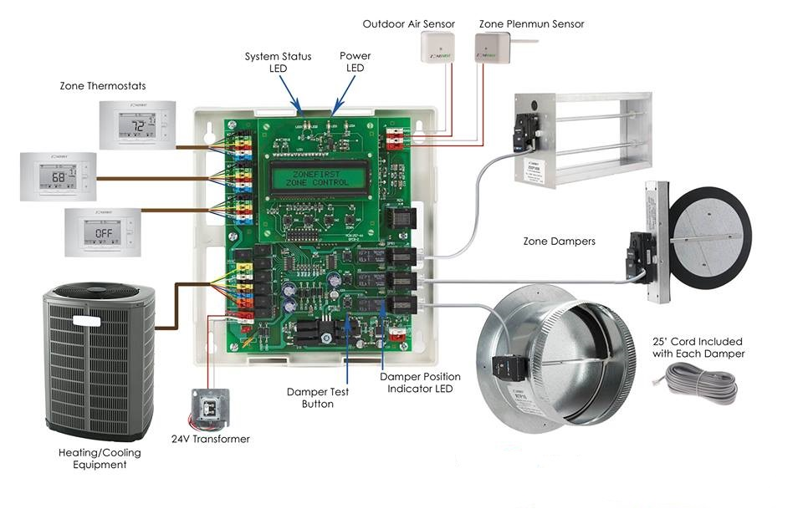

**Figure 2. HVAC control system structure**

## 2.1 Thermostat Functions

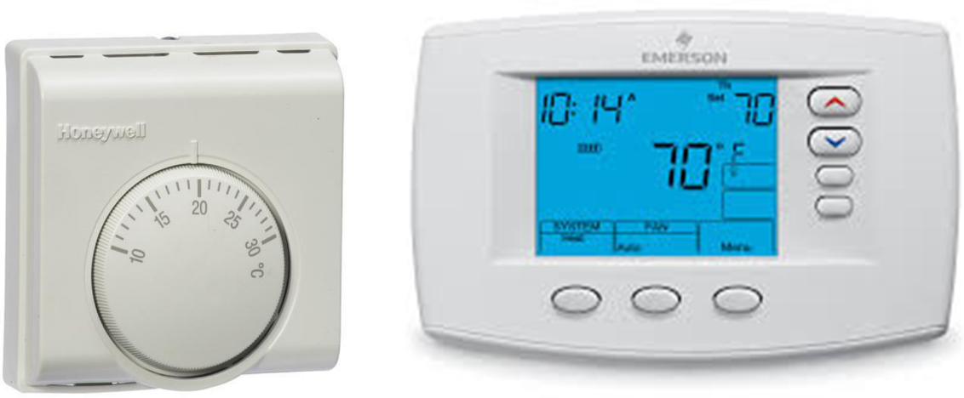

**Figure 2.1 Thermostat**

For a HVAC system with Heating/Cooling equipment, it has two modes to choose.  when the house is too cold, the thermostat switches on the heating so things quickly warm up; once the temperature reaches the level that has been set, the thermostat switches the heating off or set it to economic mode (energy saving mode). The cooling mode is opposite. The user can also change the wind flow power (fan speed) through a modern thermostat. So It has three main functions:

* 1. Heating indoor environment to set temperature
  2. Cooling indoor environment to set temperature
  3. Change Wind Power (fan speed)

## 2.2 Thermostat connection

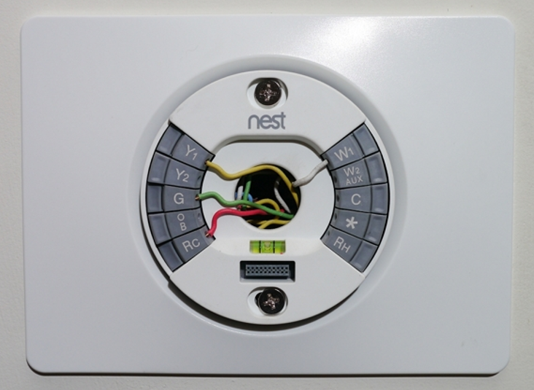

**Figure 2.2 Thermostat connection wires**

A typical connection for most houses and office building system, the function of wires is as follow:

**RC** - Red Wire (Power 24 Vac)  
**RH** or 4 - Red Wire Jumpered (Power 24 Vac)  
**W** - White Wire (For Heating Enable)  
**Y** - Yellow Wire (For Cooling Enable)  
**G** - Green Wire (Controls Fan ON-Auto)

# The System Overveiw

The HVAC control system, which is a Control panel will be used for setting the value of temperature, humidity, CO2 level they prefer through this panel. Sensors, which are assembled in one specific closed space like office or classroom, will collect the indoor environment data (temperature, relative humidity, C02 level) and translate them to the controller inside the panel. After calculating the regulation data and sensor data, the adjusting data will be created and translated to actuators like motors, valves, and dampers of HVAC system to change the indoor environment.

In the next part, the control system components will be presented with a description, specification and features of each.

# The System Components

The components used in this design are all COTS (Commercial of the shelf). They will be purchased from the respective vendor, and assembled to make the system. The components chosen are:

* STM32F103 Microcontroller
* ER-TFT070-4 7 inch TFT LCD touchscreen
* 5V 4-Channel Relay interface board
* DHT11 digital temperature and humidity sensor
* DS18B20 digital temperature sensor
* MH-Z14 NDIR Infrared CO2 sensor
* HC-SR501 PIR motion detector

## 3.1 The STM32F103 microcontroller



**Figure 3.1 STM32F103 Microcontroller**

The STM32F103 Microcontroller is produced by ST Company. It has many high level features in compare of other microcontrollers. It is one of the best in class 32 bit microcontrollers, best performance to control and connectivity in electronics projects, it is able to perform in DSP (Digital Signal Processor) solutions (High frequency performance), has low power application in order to save power for system, the speed of peripheral is increased for the better performance etc.

It is suitable for a wide range of applications such as motor drives, application control, medical and handheld equipment, PC and gaming peripherals, GPS platforms, industrial applications, PLCs, inverters, printers, scanners, alarm systems video intercom, and HVAC.

**Features:**

* Includes ST Microelectronics STM32F103 High-Performance Microcontroller with 128kBytes of Memory.
* Microcontroller features 32-Bit ARM Cortex-M3 Processor running up to 72MHz.
* Direct Full-Speed USB Computer Connection (USB 2.0 Compliant).
* Fully Assembled and Ready to Run.
* SD Card Socket.
* 1 Variable Trimpot for Adjustable Analogue Input.
* 8 Red Test LED's.
* Real Time Clock with Battery Backup.
* JTAG Connector.
* LCD Connector with Contrast Adjustment.
* 2 USART's for RS232 Connection and Program Download.
* Power and Boot LED.
* Boot and Reset Pushbutton

## 3.2 The “ER-TFT070-4” 7-inch Touchscreen

For the HVAC control system, the project team has chosen a 7 inch TFT LCD module which is capacitive. The model is ER-TFT070-4 from Eastrising technology which is based in China.

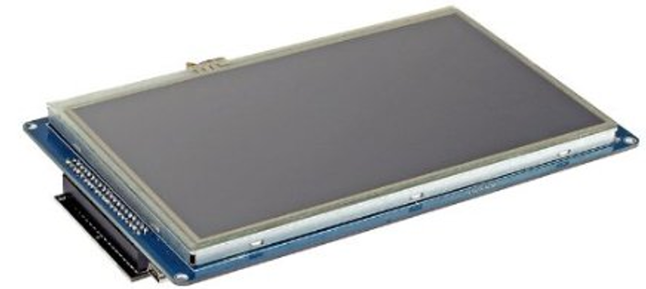

**Figure 3.2** “**ER-TFT070-4” 7-inch Touchscreen**

When it comes to the display properties of the model, it runs on an 800x480 resolution. It also has support for up to 256k colors. It has a 20ms response time, and its viewing angle range is up to 60 degrees from all four sides. It has support for I2C and SPI which makes it good for connecting to a micro controller unit. It also has support to 3.3V and 5V which makes it very versatile.

When it comes to cost it’s not very expensive either. The price ranges from 35 USD to 30 USD depending on how many units you order. These specifications fit well into our proposed design concept and the pricing makes it very attractive. Below you can see the full specifications of the LCD display:

**Specification:**

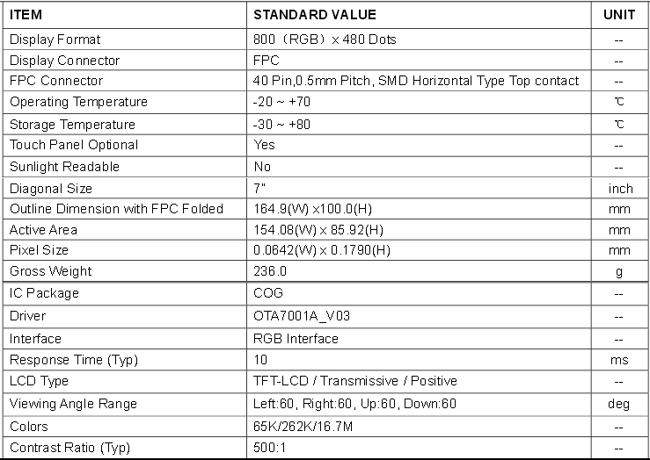

**Table 3.2 “ER-TFT070-4” 7-inch Touchscreen Specification**

## 3.3 The 4-Channel Relay Module



**Figure 3.3 The 4-Channel Relay Module**

This is a 5V 4-Channel Relay interface board, able to control various appliances, and other equipments with large current. It can be controlled directly by a wide range of microcontrollers such as[Raspberry Pi](https://github.com/fixedd/RPi_SainSmart_Interface#readme), Arduino, 8051, AVR, PIC, DSP, ARM, ARM, MSP430, TTL logic.

* 5V 4-Channel Relay interface board, and each one needs 15-20mA Driver Current
* Equipped with high-current relay, AC250V 10A; DC30V 10A
* Standard interface that can be controlled directly by microcontroller (Arduino, 8051, AVR, PIC, DSP, ARM, ARM, MSP430, TTL logic active low)
* Opto-isolated inputs
* Indication LED’s for Relay output status

## 3.4 The DHT11 Humidity-Temperature Sensor



**Figure 3.4 “DHT11” Humidity-Temperature Sensor**

DHT11 digital temperature and humidity sensor is a composite sensor that contains a calibrated digital signal output of the temperature and humidity. Application of a dedicated digital modules collection technology and the temperature and humidity sensing technology, to ensure that the product has high reliability and excellent long-term stability. The sensor includes a resistive sense of wet components and an NTC (Negative temperature coefficient) temperature measurement devices, and connected with a high-performance 8-bit microcontroller.

**Specification:**

- Humidity measuring range: 20% ~ 90% RH (0-50° C temperature compensation)  
- Temperature measuring range: 0 ~ +50°C  
- Humidity measuring accuracy: 5.0% RH  
- Temperature measurement accuracy: 2.0 C  
- Response time: (Updated by Rob Tillaart: now < 50 ms)  
- Low power consumption  
**Features:**  
- Single wire digital interface ( the most simple system integration, ultra-low prices )  
- Ultra-small size ( 12X15.5X5.5 mm )  
- High reliability  
- Optimized long-term stability

## 3.5 The Temperature Sensor (DS18B20)



**Figure 3.5 “DS18B20” Temperature Sensor**

This is a highly accurate and reliable temperature sensor for the Raspberry Pi. The DS18B20 digital thermometer provides 9-bit to 12-bit Celsius temperature measurements and has an alarm function with nonvolatile user-programmable upper and lower trigger points. The DS18B20 communicates over a 1-Wire bus that by definition requires only one data line (and ground) for communication with a central microprocessor. It has an operating temperature range of -55°C to +125°C and is accurate to ±0.5°C over the range of -10°C to +85°C. In addition, the DS18B20 can derive power directly from the data line ("parasite power"), eliminating the need for an external power supply.

**Features:**

* Unique 1-Wire® Interface Requires Only One Port Pin for Communication
* Each Device has a Unique 64-Bit Serial Code Stored in an On-Board ROM
* Multidrop Capability Simplifies Distributed Temperature-Sensing Applications
* Requires No External Components
* Can Be Powered from Data Line; Power Supply Range is 3.0V to 5.5V
* Measures Temperatures from -55°C to +125°C (-67°F to +257°F)
* 0.5°C Accuracy from -10°C to +85°C
* Thermometer Resolution is User Selectable from 9 to 12 Bits
* Converts Temperature to 12-Bit Digital Word in 750ms (Max)

## 3.6 MH-Z14 CO2 Sensor

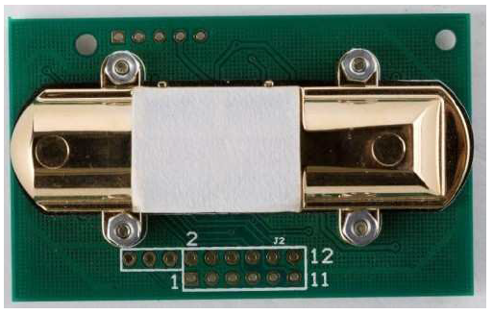

**Figure 3.6 MH-Z14 CO2 Sensor**

For [HVAC](https://en.wikipedia.org/wiki/HVAC) applications, CO2 sensors can be used to monitor the quality of air and the tailored need for fresh air, respectively. Measuring CO2 levels indirectly determines how many people are in a room, and ventilation can be adjusted accordingly.

MH-Z14 NDIR Infrared gas module is a common type, small size sensor, using non-dispersive infrared (NDIR) principle to detect the existence of CO2 in the air, with good selectivity, non-oxygen dependent, long life. Built-in temperature sensor can do temperature compensation; and it has digital output and analog voltage output. MH-Z14 NDIR Infrared gas module is applied in the HVAC, indoor air quality monitoring, industrial process, safety and protection monitoring.

**Specification:**

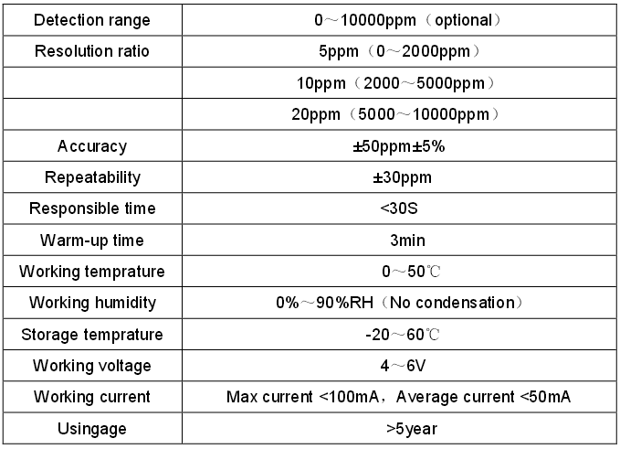**Table 3.6 MH-Z14 CO2 Sensor Specification**

## 3.7 The “HC-SR501” PIR Motion Detector



**Figure 3.7 “HC-SR501” PIR Motion Detector**

PIR sensors allow you to sense motion, almost always used to detect whether a human has moved in or out of the sensors range. They are small, inexpensive, low-power, easy to use and don't wear out. For that reason, they are commonly found in appliances and gadgets used in homes or businesses. They are often referred to as PIR, "Passive Infrared", "Pyroelectric", or "IR motion" sensors

**Specification:**

* Use BISS0001 signal processing IC, Sanyo genius regulator
* Voltage: 5V – 20V
* Power Consumption: 65mA
* TTL output: 3.3V, 0V
* Delay time: adjustable (0.3 sec – 10 minutes)
* Lock time: 0.2 sec
* Trigger methods: L – disable repeat trigger, H enable repeat trigger
* Sensing range: less than 120 degrees, within 7 meters
* Temperature: – 15 ~ +70
* Dimension: 32*24 mm, distance between screw 28mm, M2, Lens dimension in diameter: 23mm

**Features:**

* Automatic detecting: the output will be high when objects enter the sensing range, and automatically turn to low when object leave
* Photosensitive control (optional, not factory-set yet) can be set.
* Temperature compensation (optional, factory reset): In the summer when the ambient temperature rises to 30 ° C to 32 ° C, the detection distance is slightly shorter, temperature compensation can be used for performance compensation.
* Working mode (set by jumper)
  + **Non-repeatable trigger/ delay mode (set to LOW)**: the sensor will turn to low TTL after the delay, even the sensing object is still in range.
  + **Repeatable trigger (set to HIGH)**: the sensor will not turn to low if the object still staty in the sensing range in the delay time.
* Wide operating voltage range: default voltage DC4.5V-20V.
* Micro-amp power level consumption: static current <50 microamps, particularly suitable for battery-powered automatic control products.
* Output high signal: easy to achieve docking with the various types of circuit.

# The Bill of Materials

The following table 5. depicts the prices of different components of the system, and that will indicate approximatively the financial budget of the system design which will be somewhere around 144 US dollars. As a result, if the project is carried out and a prototype is yet to be built, tested, and launched it will not be expensive in terms of materials used.

|  |  |  |
| --- | --- | --- |
| ITEM | Description | Price US $ |
| 1. ARM STM32F103 MCU | Microcontroller | 3 |
| 2. ER-TFT070-4 TFT LCD | 7 inch TFT LCD touchscreen | 30 |
| 3. 4-Channel Relay | 5V 1-Channel Relay Module | 5 |
| 4. 1-Channel Relay | 5V 4-Channel Relay Module | 9 |
| 5.DHT11 sensor | Temperature and humidity sensor | 5 |
| 6. DS18B20 sensor | Temperature sensor | 10 |
| 7.MH-14 sensor | NDIR Infrared CO2 sensor | 79 |
| 8.HC-SR501 sensor | PIR motion sensor | 3 |

**Table 5. Bill of Materials**

# System Block Diagram

The core subsystem is the microcontroller that will interact with the different main components of the HVAC control system, it communicates with the users through the 7-inch Touch screen (UI), with different sensors through wires and the GPIO (general purpose input/output) and the UART ([Universal asynchronous receiver/transmitter](https://en.wikipedia.org/wiki/Universal_asynchronous_receiver/transmitter)). The microcontroller will also connect using the GPIO to the relays which will finally get to act accordingly on the HVAC controller and Humidifier and get the appropriate change in the indoor environment. The figure 5. Depicts the system block diagram.

In addition to the existing HVAC system a humidifier is added as an independent component that will interact with the microcontroller through the 1-channel relay module.



**Figure 5. The System Block Diagram**

# Reference

<https://www.qb50.eu/index.php/design-review/cdr>

https://arduino-info.wikispaces.com/DHT11-Humidity-TempSensor

<http://akizukidenshi.com/download/ds/aosong/DHT11.pdf>

<https://www.futurlec.com/Datasheet/Sensor/MH-Z14.pdf>

<https://www.mpja.com/download/31227sc.pdf>

<http://www.electrodragon.com/product/pir/>

<http://www.espruino.com/datasheets/STM32F103xC.pdf>

<http://www.futurlec.com/STM32_Development_Board.shtml>

<https://www.sparkfun.com/products/13678>

<https://www.embeddedarm.com/documentation/third-party/RV800480T-7X0WP-A3.pdf>

<http://rancidbacon.com/files/kiwicon8/ESP8266_WiFi_Module_Quick_Start_Guide_v_1.0.4.pdf>

<http://www.sainsmart.com/4-channel-5v-relay-module-for-pic-arm-avr-dsp-arduino-msp430-ttl-logic.html>

<http://ha.privateeyepi.com/store/index.php?route=product/product&product_id=63>